CHAPTER-2
Electrodes
A bio signal is any signal in living beings that can be continually measured and monitored. The term bio signal is often used to refer to bioelectrical signals, but it may refer to both electrical and non-electrical signals. The usual understanding is to refer only to time-varying signals, although spatial parameter variations (e.g. the nucleotide sequence determining the genetic code) are sometimes subsumed as well.
Electrical biosignals
Electrical biosignals, or bioelectrical time signals, usually refers to the change in electric current produced by the sum of an electrical potential difference across a specialized tissue, organ or cell system like the nervous system. Thus, among the best-known bioelectrical signals are:
- Electroencephalogram (EEG)
- Electrocardiogram (ECG)
- Electromyogram (EMG)
- Mechanomyogram (MMG)
- Electrooculography (EOG)
- Galvanic skin response (GSR)
- Magneto encephalogram (MEG)
EEG, ECG, EOG and EMG are measured with a differential amplifier which registers the difference between two electrodes attached to the skin. However, the galvanic skin response measures electrical resistance and the MEG measures the magnetic field induced by electrical currents (electroencephalogram) of the brain.
With the development of methods for remote measurement of electric fields using new sensor technology, electric biosignals such as EEG and ECG can be measured without electric contact with the skin. This can be applied for example for remote monitoring of brain waves and heartbeat of patients who must not be touched, in particular patients with serious burns.
Electrical currents and changes in electrical resistances across tissues can also be measured from plants.
Biosignals may also refer to any non-electrical signal that is capable of being monitored from biological beings, such as mechanical signals (e.g. the mechanomyogram or MMG), acoustic signals (e.g. phonetic and non-phonetic utterances, breathing), chemical signals (e.g. pH, oxygenation) and optical signals (e.g. movements).
Bio electrodes
Bio electrodes function as an interface between biological structures and electronic systems. Electrical activity within the biological structure is either sensed or stimulated. The electrical systems are either passively sensing (measuring) or actively stimulating (inducing) electrical potentials within the biological structure or unit.
Electrical currents are generated by many biological structures. Currents give rise to potential differences that can be measured using electrodes and can be interpreted to gain insight in the functioning of the source structure. Conversely, current can be applied to the biological structure through electrodes to affect the target.
The same electrode may function either passively or actively, depending on the purpose and the electronic system controls. An example seen on TV is the large defibrillation paddles used by paramedics to resuscitate people in cardiac distress. When the paddles are applied to a patient, the electrical system is programmed to first passively sense the electrical activity (or lack of) within the heart. Then the electrical system uses algorithms to determine if a stimulation (shock) is required, and finally to provide the appropriate electrical stimulation.
The size of bio electrodes ranges from microscopic intra-cellular research electrodes to large (3 x 5-inch) defibrillation paddles.
Most bio electrodes are made of metal, but the microscopic intra-cellular research electrodes are glass capillary tubes filled with a conductive saline solution.
Contact impedance
Electrical Impedance Tomography (EIT) applies current and measures the resulting voltage on the surface of a target. In biomedical applications, this current is applied, and voltage is measured, through electrodes attached to the body. Models are used to represent these electrode connections in the reconstruction of the conductivity image, tying circuit models to Finite Element Method (FEM) simulations. Changes in the contact impedance or boundary shape relative to the electrode’s surface area can introduce artifacts in the reconstructed image. The quantity and quality of these artifacts is dependent upon the electrode model and the properties assigned to that model. The electrode models were originally formulated in the context of mathematical proofs of solution existence and uniqueness for EIT (Calder´on 2006, Nachman 1996). The Complete Electrode Model (CEM) allows a complex impedance for each electrode that models the metal electrode, conductive gel and chemical interaction at the skin electrode interface (Cheng et al. 1989, Somersalo et al. 1992). The FEM is used in the numerical solution of EIT images. The simplest electrode model to implement in the FEM is the Point Electrode Model (PEM) which applies current and measures voltage at single nodes on the boundary and requires no further equations to implement. The PEM does not consider the geometry or contact impedance of an electrode. To reconstruct accurate images from in vivo data, an accurate electrode model is frequently required, and thus, the CEM is generally preferred
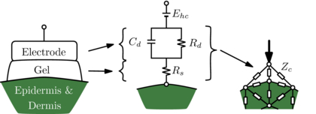
Generalized electrode model

Electrodes in Biomedical Instrumentation

Electrodes are devices that convert ionic potentials into electronic potentials. The type of electrode used for the measurements depends on the anatomical location of the bioelectric event to be measured. In order to process the signal in electronic circuits, it will be better to convert ionic conduction into electronic conduction. So simply bio-electrodes are a class of sensors that transduces ionic conduction into electronic conduction. The purpose of bio-electrodes is to acquire bioelectrical signals such as ECG, EMG, EEG etc.
Electrodes are mainly classified into two. They are perfectly polarized electrodes and perfectly non-polarized electrodes. There are a wide variety of electrodes which can be used to measure bioelectric events. The three main classes of electrodes are Microelectrodes, Body Surface electrodes and Needle electrodes.
A. Microelectrodes are electrodes with tips having tips sufficiently small enough to penetrate a single cell in order to obtain readings from within the cell. The tips must be small enough to permit penetration without damaging the minute cell. The main functions of microelectrodes are potential recording and current injection. Microelectrodes are having high impedances in mega ohm range because of their smaller size. Microelectrodes are generally of two types. With the use of a microelectrode or an array of microelectrodes, researchers can gather all sort of information regarding living organism.
- Metal type
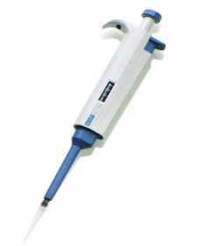
- Micropipette type
a. Metal microelectrode: Metal microelectrodes are formed by electrolytic ally etching the tip of fine tungsten to the desired size and dimension. Then the wire is coated almost to the tip with any type of insulating material. The metal-ion interface takes place where the metal tip contacts the electrolyte. The main features of metal microelectrodes are
1. Very good S/N ratio
2. Strong enough to penetrate
3. High biocompatibility
b. Micropipette: The micropipette type of microelectrode is a glass micropipette with its tip drawn out to the desired size. The micropipette is filled with an electrolyte which should be compatible with the cellular fluids. A micropipette is a small and extremely fine pointed pipette used in making microinjections. A commercial type of micropipette is shown in figure below.
B. Body Surface Electrodes:
Surface electrodes are those which are placed in contact with the skin of the subject in order to obtain bioelectric potentials from the surface. Body surface electrodes are of many sizes and types. In spite of the type, any surface electrode can be used to sense ECG, EEG, EMG etc. The various types of body surface electrodes are discussed below. Major body surface electrodes are
1. Immersion electrodes: They are one of the first type of bioelectric measuring electrodes. Immersion electrodes were simply buckets of saline solution in which the subject placed his hands and feet. So it was not a comfortable type of measurement and hence it was replaced with plate electrodes.
2. Plate electrodes: These electrodes were separated from subject’s skin by cotton pads socked in a strong saline solution. The plate electrodes have generally smaller contact area and they do not totally seal on the patient. The electrode slippage and displacement of plates were the major difficulties faced by these type of electrodes because they have a tendency to lose their adhesive ability as a result of contact with fluids on or near the patient. Since these types of electrodes were very sensitive, it led to measurement errors.
3. Floating electrodes: These types of electrodes can eliminate the movement errors (called artifacts) which is a main problem with plate electrodes. This is done by avoiding any direct contact of the metal with the skin. So the main advantage of floating electrodes is mechanical reliability. Here the conductive path between the metal and the skin is the electrolyte paste or jelly.
4. Disposable electrodes: Normally plate electrodes, floating electrodes etc. can be used more than one time. This requires the cleaning and cares after each use. We can use disposable electrodes which can be used only once and be disposed after the use. These types of electrodes are now widely used.
5. Suction electrodes: These type of electrodes are well suited for the attachment to flat surfaces of body and to regions where the underlying tissue is soft, due to the presence of contact surface. An advantage of these type of electrodes is that it has a small surface area. These types of electrodes are mainly used for the measurement of ECG. Suction electrodes used a plastic syringe barrel to house suction tubing and input cables to an AC amplifier.
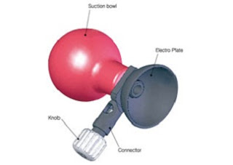
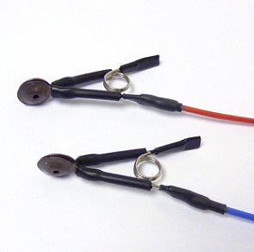
6. Ear clip & Scalp electrodes: These type of electrodes is widely used in the measurement of EEG exclusively. Scalp electrodes can provide EEG easily by placing it over bare head. A typical ear clip electrode is shown in figure below. The most common method for EEG measurement is 10 – 20 electrode placement system and here we use scalp electrode usually. They can avoid measurement errors and movement errors. During labour internal monitoring may be needed and is usually in the form of an electrode placed under the baby’s scalp. It is called fetal scalp electrode which is used to monitor baby’s heartbeat while still in uterus.

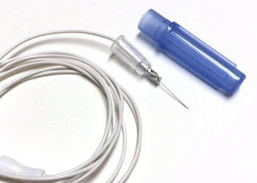
C. Needle Electrodes:
To reduce the interface and noise (artifact) caused due to electrode movement, during the measurement of EEG, EMG etc. we can use small sub-dermal needle electrodes which penetrate the scalp. Actually the needle electrodes are not inserted into the brain. They nearly penetrate the skin. Generally they are simply inserted through a small section of the skin just beneath the skin parallel to it.
The needle electrodes for EMG measurement consist of fine insulated wires placed in such a way that their tips are in contact with the muscle, nerve or other tissues from which the measurement is made. The needle creates the hole necessary for insertion and the wires forming the electrodes are carried inside it. A typical EEG needle electrode is shown in figure.
One of the main advantage of needle electrodes is that they are less susceptible to movement errors than surface electrodes. Also the needle electrodes have lower impedances when compared to surface electrodes as it makes direct contact with the sub-dermal tissues or intracellular fluid.

Chapter 4
Bio Medical Recorder
ECG
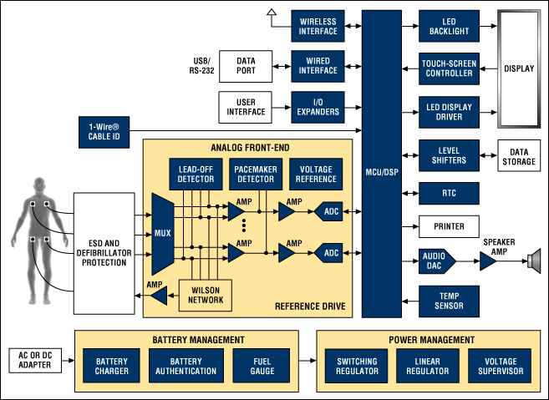
All ECGs pick up heart signals through electrodes connected externally to specific locations on the body. The heart signals are generated by the body and have amplitudes of a few millivolts. The specific locations of the electrodes allow the heart's electrical activity to be viewed from different angles, each of which is displayed as a channel on the ECG printout. Each channel represents the differential voltage between two of the electrodes, or the differential voltage between one electrode and the average voltage from several electrodes. The different combinations of electrodes allow more channels to be displayed than there are electrodes. The channels are commonly referred to as "leads," so a 12-lead ECG device has 12 separate channels displayed graphically. The number of leads varies from 1 to 12 depending on the application. Unfortunately, the wires running to the electrodes are occasionally referred to as leads as well. This can create confusion, as a 12-lead (12-channel) ECG device only requires 10 electrodes (10 wires), so be careful of the context in which "lead" is used. In addition to the biological signals, most ECGs also detect two manmade signals. The most important of these signals comes from implanted pacemakers and is referred to simply as "pace." The pace signal is relatively short, tens of microseconds to a couple of milliseconds, with an amplitude ranging from a few millivolts to nearly a volt. Often, the ECG must detect the presence of a pace signal while simultaneously preventing it from distorting the signals from the heart.
The second manmade signal is for detecting "lead-off," which is when an electrode is making poor electrical contact. Many ECG devices must provide an alert when this poor contact occurs. Therefore, the ECG device generates a signal to measure the impedance between the electrode and the body for detecting a lead-off occurrence. The measurement may be AC, DC, or both. In some ECG devices, respiration rate is also detected by analysing the impedance from the lead-off measurement. Lead-off detection is continuous and should not interfere with accurate measurement of the heart signals.
Modern heart rate monitors usually comprise two elements: a chest strap transmitter [needs update] and a wrist receiver (which usually is a smartwatch). In early plastic straps, water or liquid was required to get good performance. Early units have used conductive smart fabric with built-in microprocessors that analyse the electrical activity to determine the heart rate similar to an EKG. More recent devices use optics to measure heart rate by which measures changes in blood flow by shining a light from an LED through the skin and measuring how it scatters off blood vessels.
Electroencephalography - EEG
EEG records the electrical activity over an area of brain tissue. Electrical activity in the brain is generated by depolarization of neurons. As the electrical activity provided by a single neuron is too small to be detected, recorded telemetry EEG represents the summation of electrical activity from a large number of neurons in an area.
Electrodes can be placed on the surface of the brain for cortical surface EEG, or deeper into the tissue to measure from a particular area of interest. EEG can be applied to the study of neurological disorders, such as seizure detection or epilepsy studies and pharmacological studies into neurostimulating drugs. EEG can also be used in behavioural research to study brain activity patterns in response to stimuli or in studies of sleep-wake cycles. Both the Rat and Mouse Telemetry Systems allow recording of EEG from animals living in their home cages free from the stress and restriction of using tethers.
Below is an example of EEG recorded in a rat using the TR50BB telemeter with simultaneous nuchal EMG recordings in a study of the sleep-wake cycle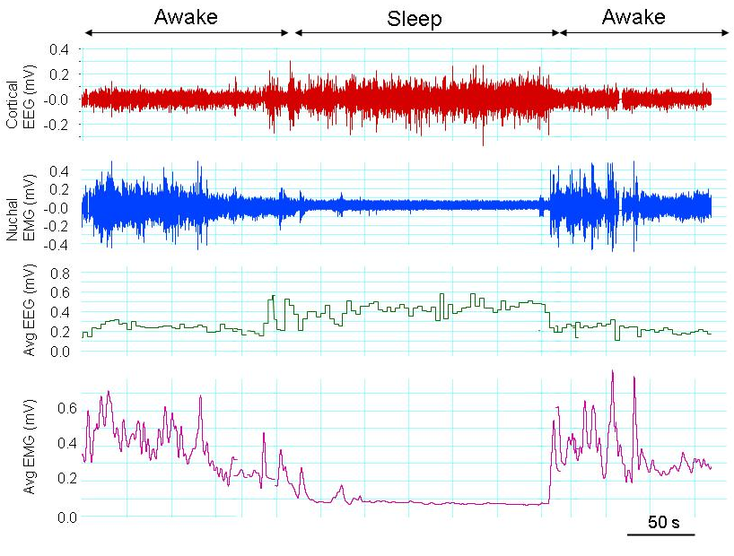.

In addition to EMG, it is possible to record EEG in conjunction with brain oxygen (TR50B + TR57Y) or intracranial pressure (TRM54PB) using the Rat Telemetry System.
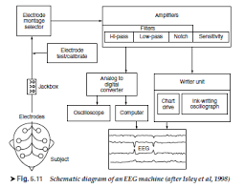
EEG Block Diagram
Electromyography - EMG
EMG records the electrical potential and the change in potential (electrical activity) across the skeletal muscle. The electrical potential changes during contraction and relaxation of the skeletal muscle as the muscle depolarizes and then repolarizes. EMG can be used to assess the muscle contraction, mechanics or inferring movement rates across the muscle. For example, attaching the lead wires to the diaphragm allows for the measurement of respiration rate, while attachment of the lead wires to the gluteus Maximus muscle can be used to assess walking or movement. Other potential applications include measurement of gastrointestinal peristaltic movements and movement of specific muscles such as nuchal EMG.
Below is an example of the EMG signal recorded from the gluteus Maximus muscle in a walking rat.

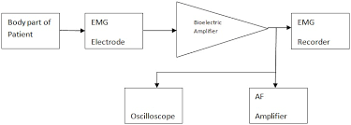 EMG Block Diagram

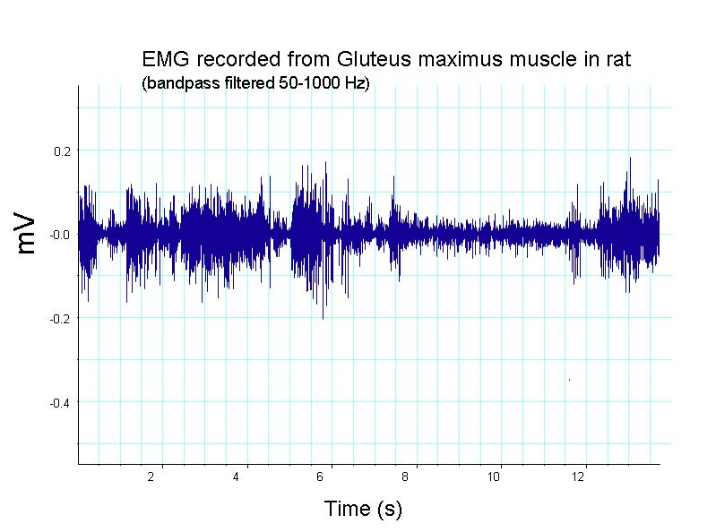
EMG can be recorded from a muscle or muscle groups, provided that the size of the muscle is large enough for the attachment of the two electrodes with a gap to prevent contact between the electrodes. It is important that the electrodes do not contact as this results in electrical shortening, and a signal will not be detected. It is also important that the electrodes are tied securely to the muscle that is being recorded from to minimize movement artifacts.
Telemetry is advantageous over tethered systems for measuring EMG as the rats and mice are allowed to move freely in their home cage eliminating behavioural adaptations to tethering. The battery of the rat telemeters also allows recording of EMG away from the home cage and tethers, opening up opportunities such as EMG recordings during behavioural tests. Rat bio potential telemeters provide up to 4 hours of continuous data transmission powered by a rechargeable battery when the rat telemeter is not actively being powered by the Smart Pad.
Phonocardiogram Block Diagram
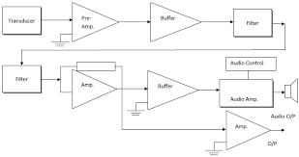

Chapter 5
Patient Monitoring System
Pulse rate monitor
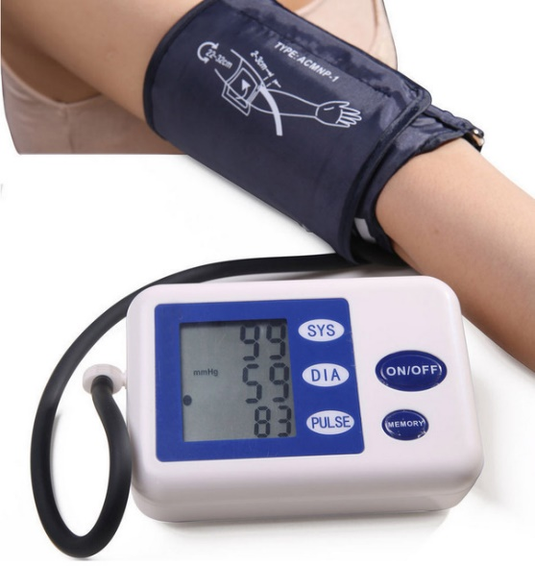
Strapless heart rate monitors (often referred to as "wearables") now allow the user to just touch two sensors on a smartwatch display for a few seconds to view heart rate data. These are popular for comfort and ease of use, though they don't give as much detail as monitors that use a chest strap. Some models of these variations of heart rate monitors use either infrared light or red visible light to measure the heart rate, as opposed to two or more electrodes. In addition to measuring the heart rate, devices using this technology are able to measure blood oxygen saturation (SpO2)
More advanced models offer measurements of heart rate variability, activity, and breathing rate to assess parameters relating to a subject's fitness. Sensor fusion algorithms allow these monitors to detect core temperature and dehydration.
Another style of heart rate monitor replaces the plastic around-the-chest strap with fabric sensors - the most common of these is a sports bra that includes sensors in the fabric.
In old versions, when a heartbeat is detected a radio signal is transmitted, which the receiver uses to determine the current heart rate. This signal can be a simple radio pulse or a unique coded signal from the chest strap (such as Bluetooth, ANT, or other low-power radio link); the latter prevents one user's receiver from using signals from other nearby transmitters (known as cross-talk interference).
Newer versions include a microprocessor, which simultaneously monitors heart rate, SpO2, and other parameters. These may include sensors such as accelerometers, gyroscopes, and GPS to detect speed, location and distance eliminating the need for ankle worn devices.
There are a wide number of receiver designs, with various features. These include average heart rate over exercise period, time in a specific heart rate zone, calories burned, breathing rate, built-in speed and distance, and detailed logging that can be downloaded to a computer. The receiver can be built into a smartwatch or smartphone. Bracelets with integrated sensors work optically, and have poor accuracy.

Blood pressure monitor
A blood pressure monitor, or sphygmomanometer, uses an inflatable air-bladder cuff and a listening device or pressure sensor to measure blood pressure in an artery. This monitoring can be performed by using either of two methods: a manually inflated cuff with a stethoscope for listening to arterial wall sounds (the auscultatory method), or a blood pressure monitor that contains a pressure sensor for sensing arterial wall vibrations (the oscillometric method).
Automatic Monitor Types
The two main types of automatic blood pressure monitors are upper-arm and wrist models. The upper-arm model has a cuff that is placed on the upper arm; the cuff is connected by a tube to the monitor that rests on a surface near the arm. The wrist model is smaller and the entire unit wraps around the wrist—this is a much more space-critical design. Some upper-arm models require manual inflation of the cuff, but most upper-arm and all wrist models are fully automatic.
Measurement Techniques
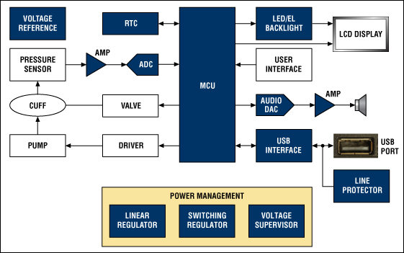
An automatic blood pressure monitor inflates a cuff surrounding an arm with sufficient pressure to prevent blood flow in the local main artery. This pressure is gradually released until the moment that the blood begins to flow through the artery, the measurement of which determines the systolic pressure. Pulse rate is also sensed at this time. The measurement taken when the blood flow is no longer restricted determines the diastolic pressure. This complete measurement cycle is performed automatically with a pump, cuff, valve, and pressure sensor.
The signal from the pressure sensor is conditioned with an op-amp circuit or by an instrumentation amplifier before data conversion by an analog-to-digital converter (ADC). The systolic pressure, diastolic pressure, and pulse rate are then calculated in the digital domain using a method appropriate for the type of monitor and sensor utilized. The resulting systolic, diastolic, and pulse-rate measurements are displayed on a liquid-crystal display (LCD), time/date-stamped, and stored in non-volatile memory.
Ventilator
A medical ventilator (or simply ventilator in context) is a mechanical ventilator, a machine designed to move breathable air into and out of the lungs, to provide breathing for a patient who is physically unable to breathe, or breathing insufficiently. While modern ventilators are computerized machines, patients can be ventilated with a simple, hand-operated bag valve mask. Ventilators are chiefly used in intensive care medicine, home care, and emergency medicine (as standalone units) and in anaesthesia (as a component of an anaesthesia machine).
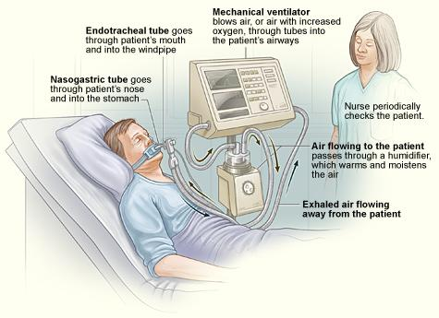
Function: - In its simplest form, a modern positive pressure ventilator consists of a compressible air reservoir or turbine, air and oxygen supplies, a set of valves and tubes, and a disposable or reusable "patient circuit". The air reservoir is pneumatically compressed several times a minute to deliver room-air, or in most cases, an air/oxygen mixture to the patient. If a turbine is used, the turbine pushes air through the ventilator, with a flow valve adjusting pressure to meet patient-specific parameters. When over pressure is released, the patient will exhale passively due to the lungs' elasticity, the exhaled air being released usually through a one-way valve within the patient circuit called the patient manifold. Ventilators may also be equipped with monitoring and alarm systems for patient-related parameters (e.g. pressure, volume, and flow) and ventilator function (e.g. air leakage, power failure, mechanical failure), backup batteries, oxygen tanks, and remote control. The pneumatic system is nowadays often replaced by a computer-controlled turbo pump. Modern ventilators are electronically controlled by a small embedded system to allow exact adaptation of pressure and flow characteristics to an individual patient's needs. Fine-tuned ventilator settings also serve to make ventilation more tolerable and comfortable for the patient. In Canada and the United States, respiratory therapists are responsible for tuning these settings, while biomedical technologists are responsible for the maintenance. The patient circuit usually consists of a set of three durables, yet lightweight plastic tubes, separated by function (e.g. inhaled air, patient pressure, exhaled air). Determined by the type of ventilation needed, the patient-end of the circuit may be either non-invasive or invasive. Non-invasive methods, which are adequate for patients who require a ventilator only while sleeping and resting, mainly employ a nasal mask. Invasive methods require intubation, which for long-term ventilator dependence will normally be a tracheotomy cannula, as this is much more comfortable and practical for long-term care than is larynx or nasal intubation.
Life-critical system: -Because failure may result in death, mechanical ventilation systems are classified as a life-critical system, and precautions must be taken to ensure that they are highly reliable, including their power-supply. Mechanical ventilators are therefore carefully designed so that no single point of failure can endanger the patient. They may have manual backup mechanisms to enable hand-driven respiration in the absence of power (such as the mechanical ventilator integrated into an anaesthetic machine). They may also have safety valves, which open to atmosphere in the absence of power to act as an anti-suffocation valve for spontaneous breathing of the patient. Some systems are also equipped with compressed-gas tanks, air compressors, and/or backup batteries to provide ventilation in case of power failure or defective gas supplies, and methods to operate or call for help if their mechanisms or software fail.

CHAPTER-6
Modern Imaging System

Ultrasonography
- Transducer probe - probe that sends and receives the sound waves
- Central processing unit (CPU) - computer that does all of the calculations and contains the electrical power supplies for itself and the transducer probe
- Transducer pulse controls - changes the amplitude, frequency and duration of the pulses emitted from the transducer probe
- Display - displays the image from the ultrasound data processed by the CPU
- Keyboard/cursor - inputs data and takes measurements from the display
- Disk storage device (hard, floppy, CD) - stores the acquired images
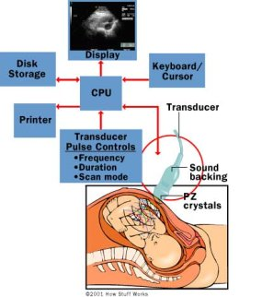
- Printer - prints the image from the displayed data

The transducer probe is the main part of the ultrasound machine. The transducer probe makes the sound waves and receives the echoes. It is, so to speak, the mouth and ears of the ultrasound machine. The transducer probe generates and receives sound waves using a principle called the piezoelectric (pressure electricity) effect, which was discovered by Pierre and Jacques Curie in 1880. In the probe, there are one or more quartz crystals called piezoelectric crystals. When an electric current is applied to these crystals, they change shape rapidly. The rapid shape changes, or vibrations, of the crystals produce sound waves that travel outward. Conversely, when sound or pressure waves hit the crystals, they emit electrical currents. Therefore, the same crystals can be used to send and receive sound waves. The probe also has a sound absorbing substance to eliminate back reflections from the probe itself, and an acoustic lens to help focus the emitted sound waves.
Transducer probes come in many shapes and sizes, as shown in the photo above. The shape of the probe determines its field of view, and the frequency of emitted sound waves determines how deep the sound waves penetrate and the resolution of the image. Transducer probes may contain one or more crystal elements; in multiple-element probes, each crystal has its own circuit. Multiple-element probes have the advantage that the ultrasound beam can be "steered" by changing the timing in which each element gets pulsed; steering the beam is especially important for cardiac ultrasound (see Basic Principles of Ultrasound for details on transducers). In addition to probes that can be moved across the surface of the body, some probes are designed to be inserted through various openings of the body (vagina, rectum, oesophagus) so that they can get closer to the organ being examined (uterus, prostate gland, stomach); getting closer to the organ can allow for more detailed views.
The CPU is the brain of the ultrasound machine. The CPU is basically a computer that contains the microprocessor, memory, amplifiers and power supplies for the microprocessor and transducer probe. The CPU sends electrical currents to the transducer probe to emit sound waves, and also receives the electrical pulses from the probes that were created from the returning echoes. The CPU does all of the calculations involved in processing the data. Once the raw data are processed, the CPU forms the image on the monitor. The CPU can also store the processed data and/or image on disk.
The transducer pulse controls allow the operator, called the ultra-sonographer, to set and change the frequency and duration of the ultrasound pulses, as well as the scan mode of the machine. The commands from the operator are translated into changing electric currents that are applied to the piezoelectric crystals in the transducer probe.
Computed tomography (CT)
Medical-imaging systems generate three-dimensional (3-D) images of internal body structures using complex x-ray and computer-aided tomographic imaging techniques.
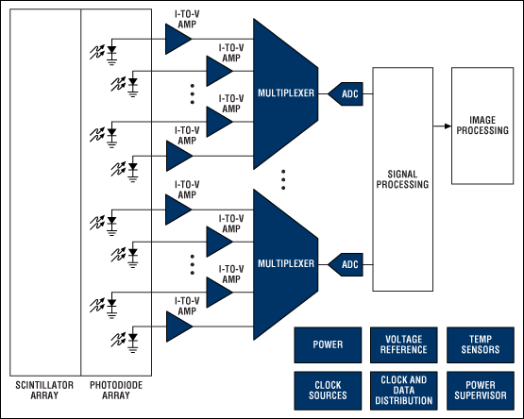
The x-ray images used to generate the tomographic images are generated first by exposing the patient to a fan-shaped x-ray beam and then detecting the projected image on a thin semi-circular, digital x-ray detector. The patient is placed between the source and detector, and the detector is configured with its geometric centre located at the x-ray source. Each image is an x-ray projection of a very thin transverse slice of the body. To collect the multitude of x-ray projections necessary to generate a tomographic CT image, both the x-ray source and detector are rotated about a patient within a supporting gantry. While the source and detector rotate, images are collected and stored. As in a traditional x-ray, the signal levels in the image slice represent the relative radio density of the patient along a line from the x-ray source to the corresponding pixel location.
To improve image-capture times and resolution, manufacturers utilize multislice CT imaging techniques. Instead of a single 2D detector array which provides only a single image slice, multislice imaging uses a 3-D array. The added imaging dimension allows the system to generate multiple slices in parallel. Photodetector arrays used in CT imaging have as many as 1000 detectors in the long dimension along the semi-circular detector arch; 16 or more detectors are positioned in the shorter dimension tangential to the arch. The number of detectors in the short dimension determines the number of available image slices.
The patient is exposed to a fan-shaped x-ray beam and the projected image is detected on a thin, semi-circular digital x-ray detector.
Modern CT imaging systems can also generate images in any plane within the body by using a technique called spiral CT. In a spiral-CT system the patient is slowly moved into the centre of the gantry while the x-ray source and detector rotate about the patient. Very-high-speed computers are necessary to process the images collected in this manner. Sophisticated tomographic imaging techniques are used to produce the required image.
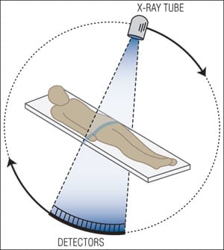
X-Ray Detection
Early CT imaging systems accomplished x-ray detection using both scintillation crystals and photo-multiplier tubes. The scintillation crystals converted x-rays to light and the photomultiplier tubes converted these light signals to a usable electrical signal. Modern CT systems now employ more sophisticated scintillation crystal materials and solid-state photodetector diodes for this purpose.
The output from each photodiode is a current proportional to the light striking the diode. These currents can be directly converted to a voltage by a low-noise trans impedance amplifier (TIA), or integrated over time using a capacitor or active integrator op-amp circuit to produce a voltage output. Integration of the current from each diode can be accomplished in multiple ways. Capacitance in the photodiode detector array itself can be used for this purpose. The signals from these capacitors are multiplexed using FET switches in the diode-array detector. The signals are then routed to the digital acquisition system (DAS) which amplifies and converts the signals to a digital format using high-resolution analog-to-digital converters (ADCs). An alternative method routes the signals from every photodiode to an integrator in the DAS. In these implementations, the integrated current signals are converted to a voltage, sampled at the same time, and multiplexed into the input of an ADC.
Tomographic Imaging
The resulting x-ray image data set is converted to an image by the image processor. The image processor is typically a very-high-speed computer which performs the massive calculations required for the tomographic image reconstruction. The resulting image will commonly have a very large dynamic range (i.e., 16-bit grayscale images). Further image processing is necessary to map this large dynamic range most effectively into the limited visible display range.

MRI scan
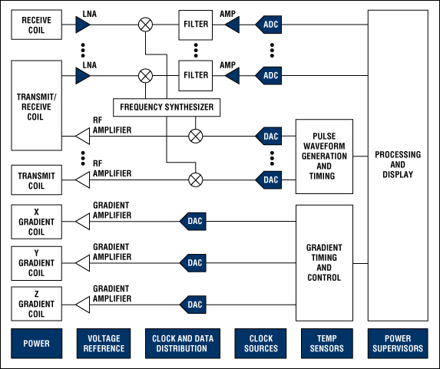
Magnetic resonance imaging (MRI) systems provide highly detailed images of tissue in the body. The systems detect and process the signals generated when hydrogen atoms, which are abundant in tissue, are placed in a strong magnetic field and excited by a resonant magnetic excitation pulse.
Magnetic resonance imaging (MRI) system.
Proper stimulation by a resonant magnetic or RF field at the resonant frequency of the hydrogen nuclei can force the magnetic moments of the nuclei to partially, or completely, tip into a plane perpendicular to the applied field. When the applied RF-excitation field is removed, the magnetic moments of the nuclei process in the static field as they realign. This realignment generates an RF signal at a resonant frequency determined by the magnitude of the applied field. This signal is detected by the MRI imaging system and used to generate an image.

Static Magnetic Field
MRI imaging requires the patient to be placed in a strong magnetic field in order to align the hydrogen nuclei. There are typically three methods to generate this field: fixed magnets, resistive magnets (current passing through a traditional coil of wire), and super-conducting magnets. Fixed magnets and resistive magnets are generally restricted to field strengths below 0.4T and cannot generate the higher field strengths typically necessary for high-resolution imaging. As a result, most high-resolution imaging systems use super-conducting magnets. The super-conducting magnets are large and complex; they need the coils to be soaked in liquid Helium to reduce their temperature to a value close to absolute zero.
The magnetic fields generated by these methods must not only be strong, but also highly uniform in space and stable in time. A typical system must have less than 10ppm variation over the imaging area. To achieve this accuracy, most systems generate weaker static magnetic fields using specialized shim coils to "shim" or "tweak" the static field from the super conductor and thereby correct for field inaccuracies.
Gradient Coils
To produce an image, the MRI system must first stimulate hydrogen nuclei in a specific 2D image plane in the body, and then determine the location of those nuclei within that plane as they process back to their static state. These two tasks are accomplished using gradient coils which cause the magnetic field within a localized area to vary linearly as a function of spatial location.

RF Receiver
An RF receiver is used to process the signals from the receiver coils. Most modern MRI systems have six or more receivers to process the signals from multiple coils. The signals range from approximately 1MHz to 300MHz, with the frequency range highly dependent on applied-static magnetic field strength. The bandwidth of the received signal is small, typically less than 20kHz, and dependent on the magnitude of the gradient field.
A traditional MRI receiver configuration has a low-noise amplifier (LNA) followed by a mixer. The mixer mixes the signal of interest to a low-frequency IF frequency for conversion by a high-resolution, low-speed, 12-bit to 16-bit analog-to-digital converter (ADC). In this receive architecture, the ADCs used have relatively low sample rates below 1MHz. Because of the low-bandwidth requirements, ADCs with higher 1MHz to 5MHz sample rates can be used to convert multiple channels by time-multiplexing the receive channels through an analog multiplexer into a single ADC.
With the advent of higher-performance ADCs, newer receiver architectures are now possible. High-input-bandwidth, high-resolution, 12-bit to 16-bit ADCs with samples rates up to 100MHz can also be used to directly sample the signals, thereby eliminating the need for analog mixers in the receive chain.
Transmitter
The MRI transmitter generates the RF pulses necessary to resonate the hydrogen nuclei. The range of frequencies in the transmit excitation pulse and the magnitude of the gradient field determine the width of the image slice. A typical transmit pulse will produce an output signal with a relatively narrow ±1kHz bandwidth. The time-domain waveform required to produce this narrow frequency band typically resembles a traditional sync function. This waveform is usually generated digitally at baseband and then up converted by a mixer to the appropriate centre frequency. Traditional transmit implementations require relatively low-speed digital-to-analog converters (DACs) to generate the baseband waveform, as the bandwidth of this signal is relatively small.
Image Signal Processing
Both frequency and phase data are collected in what is commonly referred to as the k-space. A two-dimensional Fourier transform of this k-space is computed by a display processor/computer to produce a grey-scale image.

